Assessing Skin Lesions: The 7 Point Check List (7PCL) – Original and Weighted
Original 7PCL  (Score of ≥3 suggests referral) | Weighted 7PCL  (Score of ≥3 suggests referral)
All features (equal weighting)  - Change in size of lesion  - Irregular pigmentation  - Irregular border  - Inflammation  - Itch or altered sensation  - Larger than other lesions (diameter >7mm)  - Oozing/crusting of lesion | Major features (2 points)  - Change in size of lesion  - Irregular pigmentation  - Irregular border  Minor features (1 point)  - Inflammation  - Itch or altered sensation  - Larger than other lesions (diameter >7mm)  - Oozing/crusting of lesion
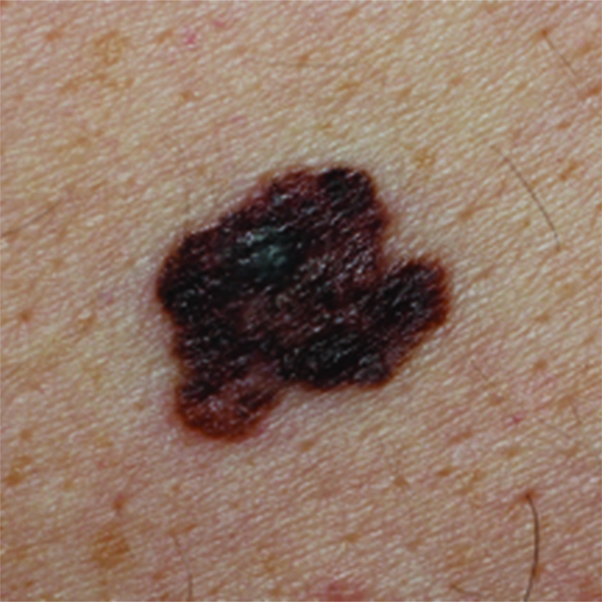 |  | 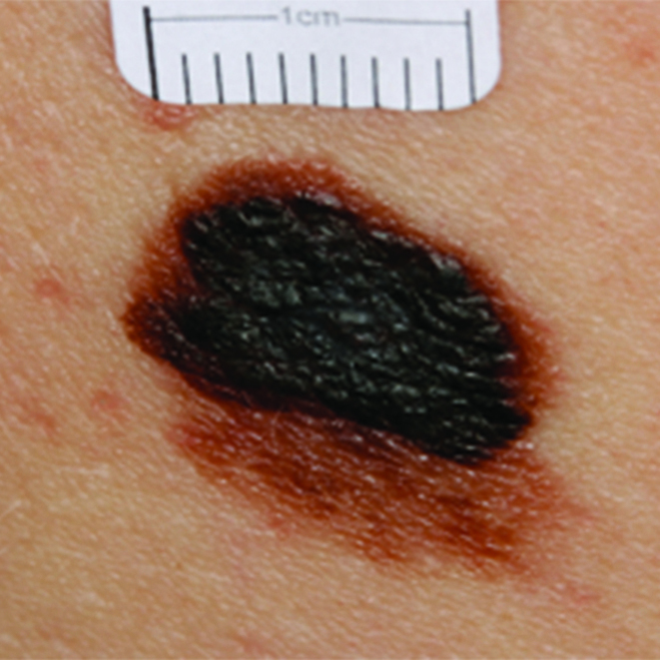
Images of early malignant melanomas to show major features: irregular pigmentation and irregular borders. Left = Early melanoma (0.8mm). Right = Early melanoma (1.0mm)

